Posting Date: July 19, 2019

CANCELLATION OF SOLICITATION

Solicitation Number: USC-BVB-3479-AS

Issue Date: April 30, 2019

Description: Turf Equipment Lease for University of South Carolina Upstate

The above referenced solicitation is cancelled in its entirety. This cancellation is based upon South Carolina Consolidated Procurement Regulation 19-445.2065 Rejection of Bids (B)(1) Cancellation of Solicitation Prior to Award for the following reason:

(a) inadequate or ambiguous specifications were cited in the invitation

The state anticipates re-soliciting for Turf Equipment Lease for University of South Carolina Upstate in the future.

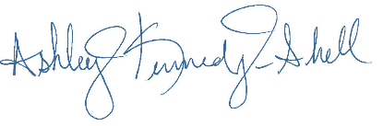

________________________________

Ashley Kennedy-Shell

Procurement Officer

